# How to execute python

There are three different ways of working in Python:

## 1) Interactive Mode:

You can enter python in the command prompt and start working with Python.

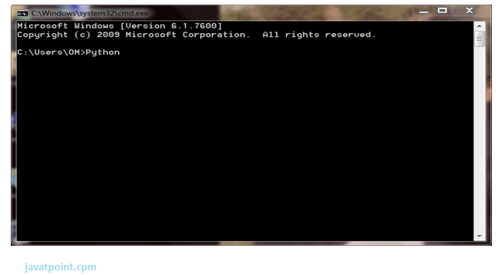

Press Enter key and the Command Prompt will appear like:

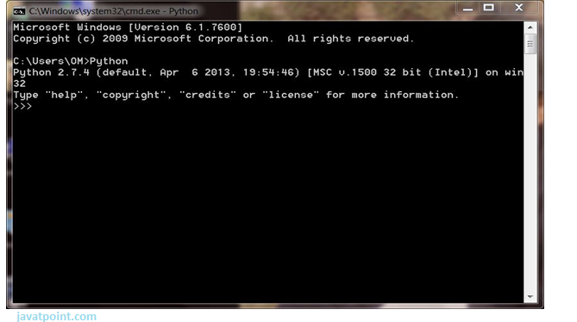

Now you can execute your Python commands.

**Eg:**

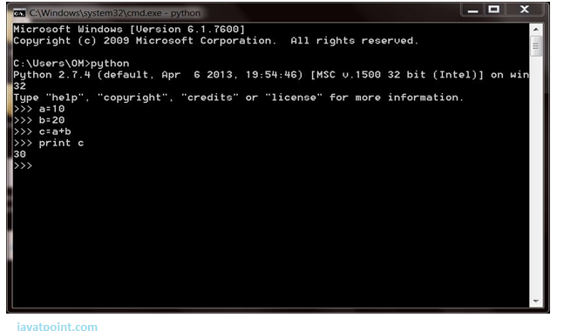

## 2) Script Mode:

Using Script Mode , you can write your Python code in a separate file using any editor of your Operating System.

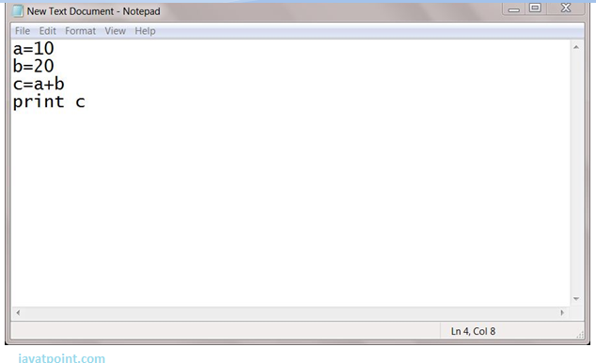

Save it by .py extension.

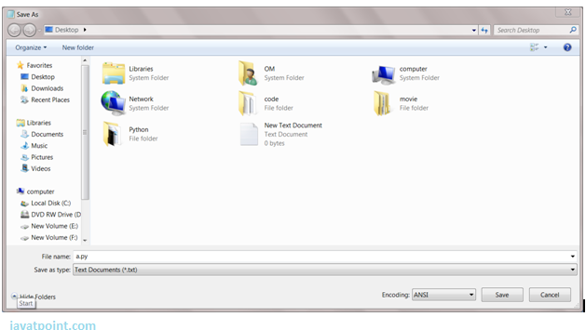

Now open Command prompt and execute it by :

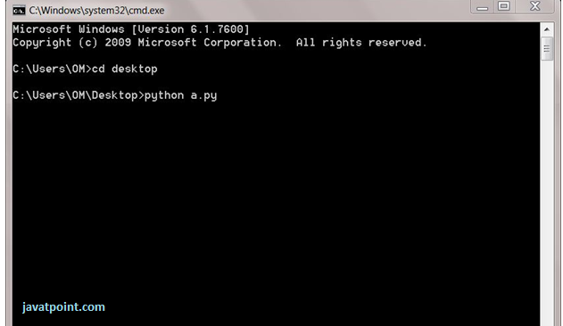

NOTE: Path in the command prompt should be where you have saved your file. In the above case file should be saved at desktop.

## 3) Using IDE: (Integrated Development Environment)

You can execute your Python code using a Graphical User Interface (GUI).

All you need to do is:

Click on Start button -> All Programs -> Python -> IDLE(Python GUI)

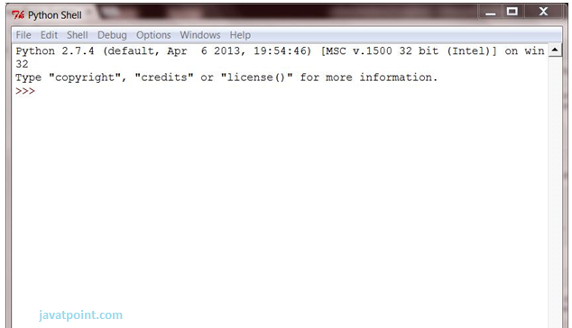

You can use both Interactive as well as Script mode in IDE.

**1) Using Interactive mode:**

Execute your Python code on the Python prompt and it will display result simultaneously.

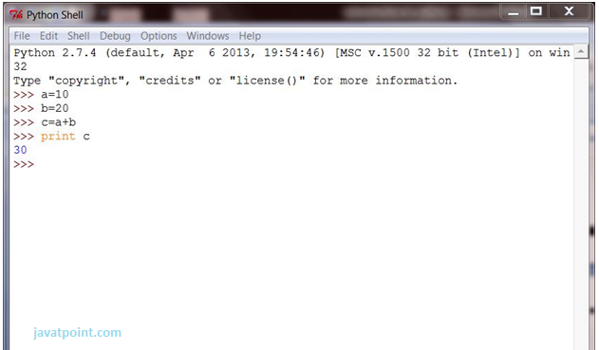

**2) Using Script Mode:**

i) Click on Start button -> All Programs -> Python -> IDLE(Python GUI)

ii) Python Shell will be opened. Now click on File -> New Window.

A new Editor will be opened . Write your Python code here.

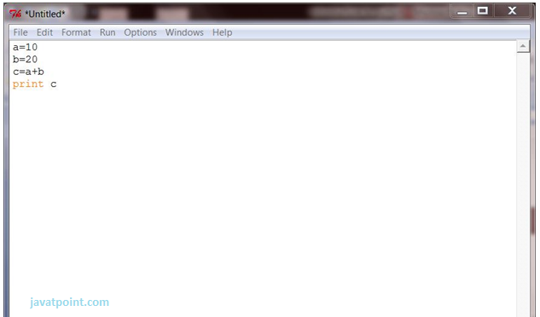

Click on file -> save as

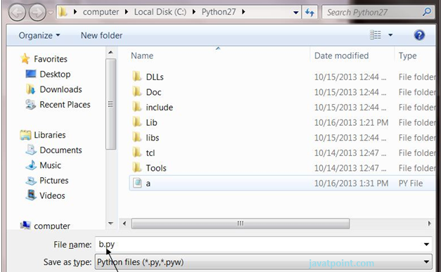

Run then code by clicking on Run in the Menu bar.

Run -> Run Module

Result will be displayed on a new Python shell as:

